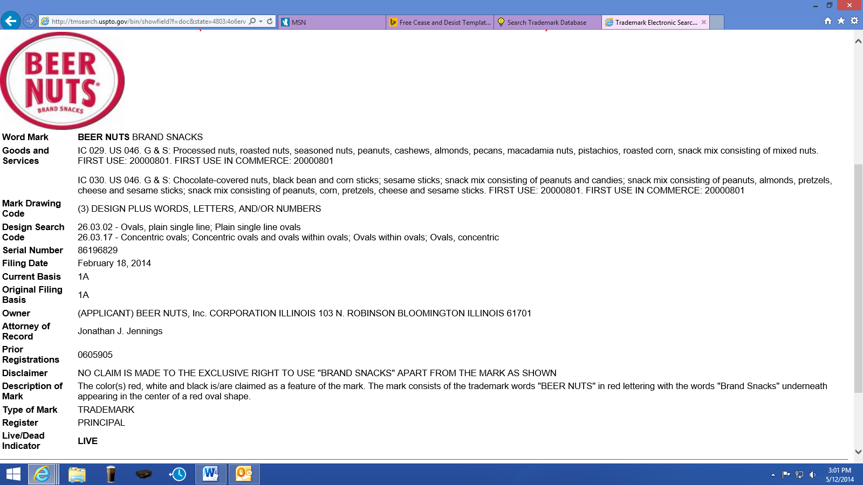
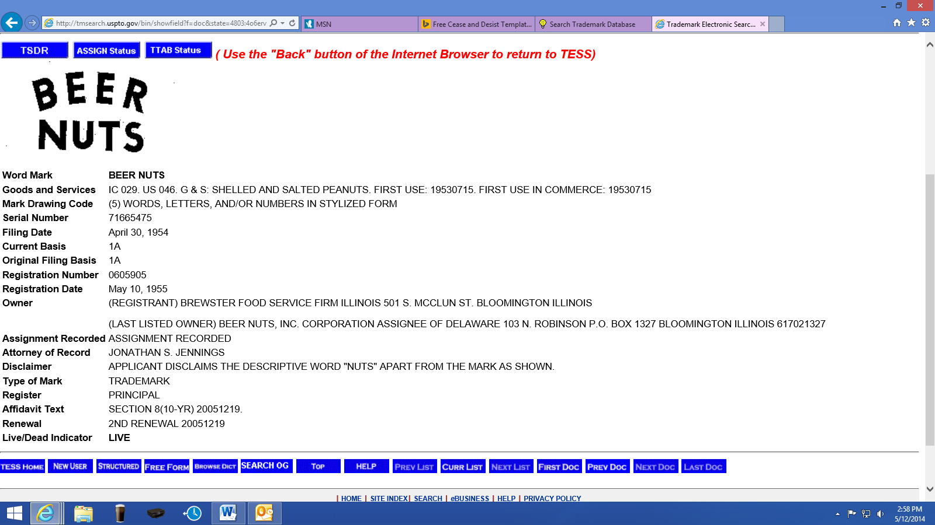
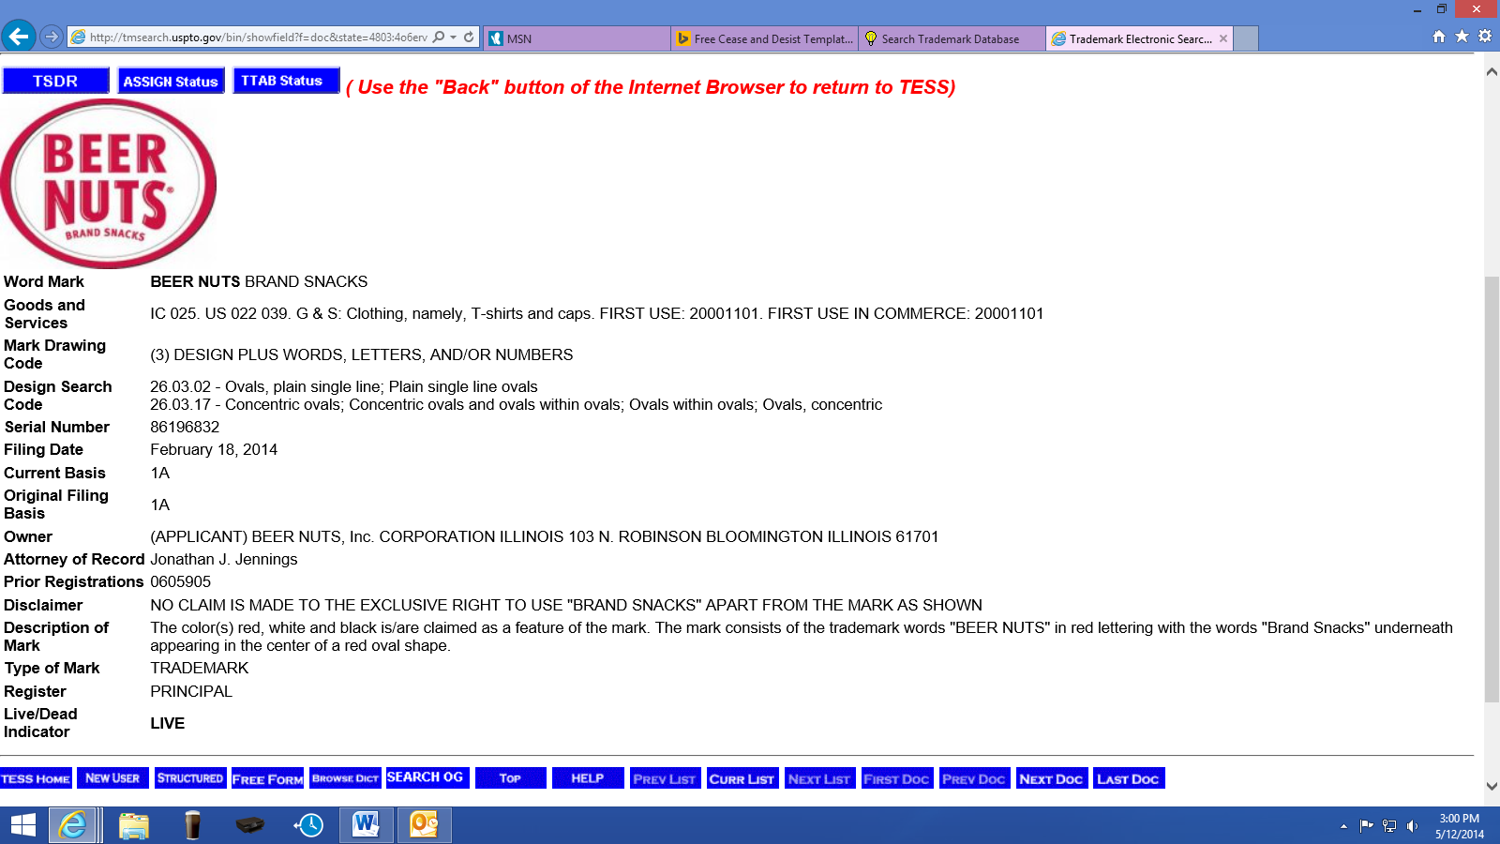
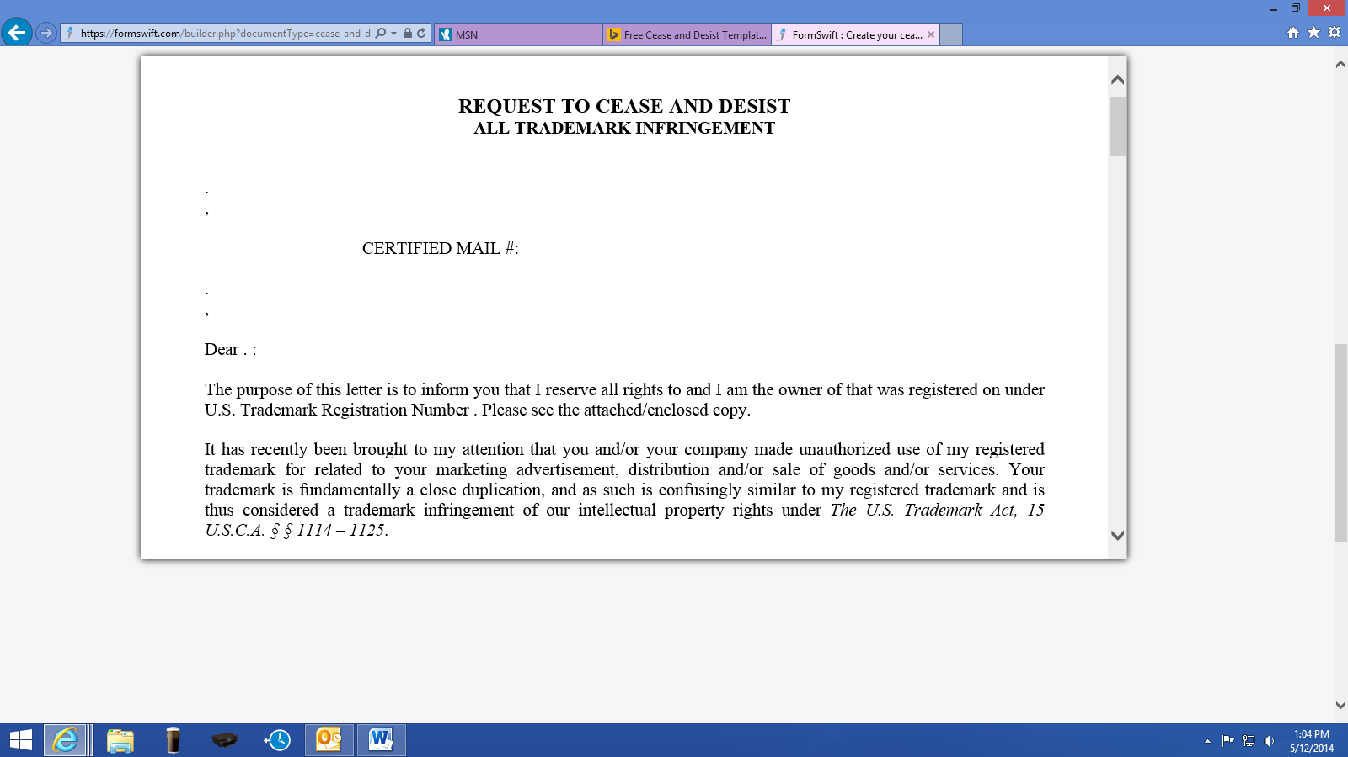
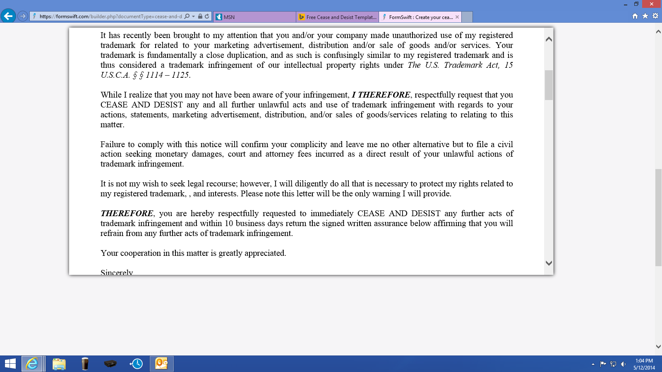

TRADEMARK INFRINGEMENT CEASE AND DESIST LETTER
Date: ____________________
To: ______________________
________________________
_________________________
Dear ___________________,
It has come to our notice that your business has been making unauthorized use of the following Trademark: ____________________________________________________ (the "Trademark") in association with the marketing or sale of your products & services. We believe it is possible that you are not unaware of this conflict, and we feel it is in our mutual interest to bring this matter to your attention.
The said Trademark is a registered trademark bearing registration no. ______________________ of our business. Registration of the trademark provides us with certain proprietary rights like the right to restrict the use of the trademark, or a confusingly similar trademark, in association with confusingly similar products or services.
As such, we own all rights and interests in the Trademark and you have neither asked for nor received any license or permission to use the Trademark. As such, we believe you have willfully infringed our rights and could be liable for statutory damages.
To resolve this matter amicably, we demand that within the next ___________________ business days of the date of this letter you voluntarily cease and desist from the use of the Trademark, and any combination of the same, in any and all products or services. If you fail to cease using the Trademark within such time, we will take appropriate steps to enforce our rights.
Also, we request you to return any and ALL material bearing the Trademark and anything substantially or confusingly similar to it and also provide an accounting of gross sales till date.
Very truly yours,

