
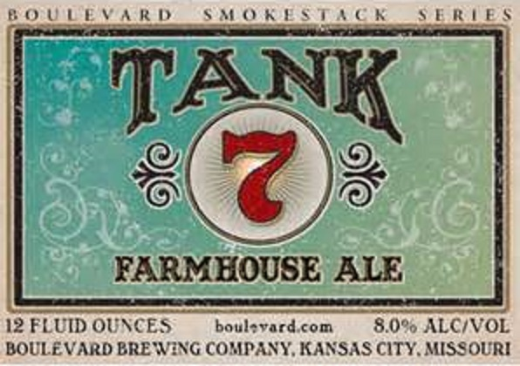
6¾

7.3% ABV

Brewer: Steven Prochaska (CR Beer Nuts)
2

