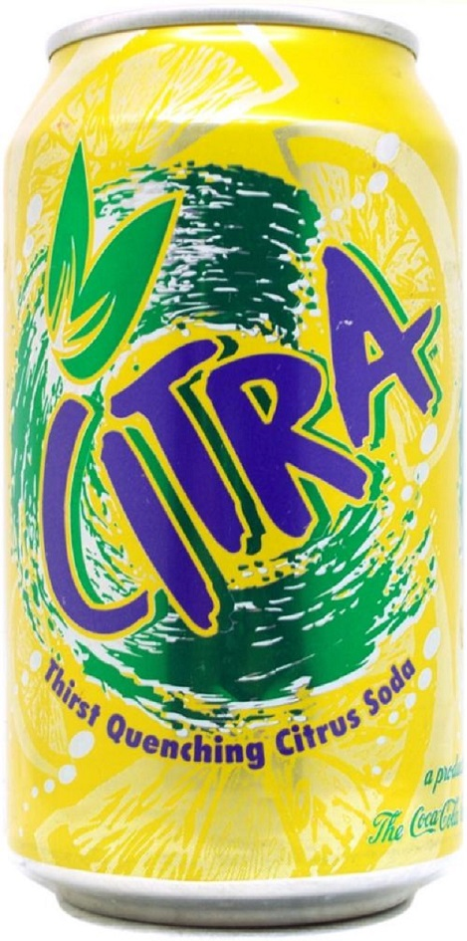
SMASH PALE ALE
4.7% ABV
Brewer: Tim Sines (CR Beer Nuts)
1
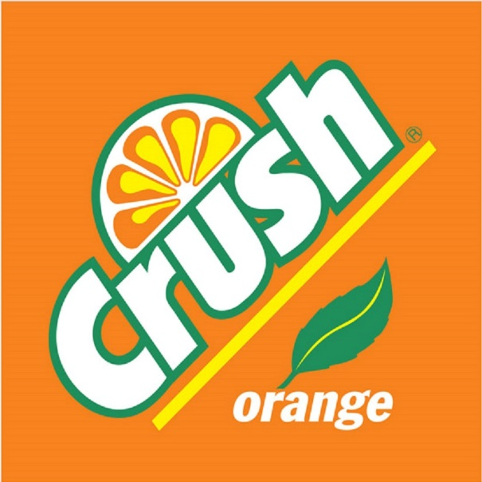
Dry “Oranged” Wit
4.7% ABV
Brewer: Tim Sines (CR Beer Nuts)
1

