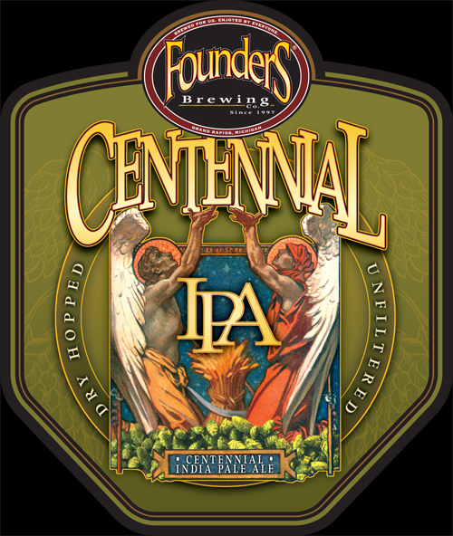
FlounderS
BI

7.0% ABV
Brewer: Randy Carris (CR Beer Nuts)
9

