FREE BEER SAMPLES
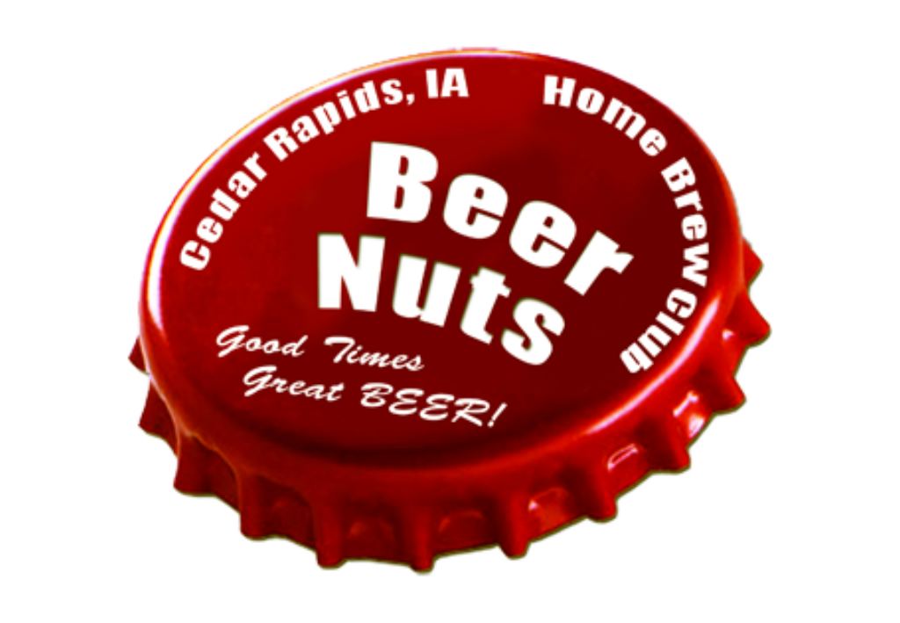
Your CR Beer Nuts Brewers/Hosts for today are:
Tony, Pat, Karl, Josh, Kurt, Derek and Andrew
RELAX - HAVE A HOME BREW!
Sponsored by the Cedar Rapids Beer Nuts Home Brew Club, from 3-5 PM on the last Sunday of the month at Lion Bridge.
We will also be pouring at our own Homebrew Beer Festival on August 20th, ask any member for details.

